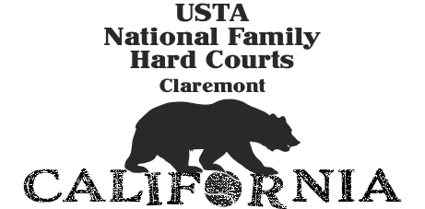
Welcome to Claremont
Our Favorite Restaurants in Claremont

Breakfast/Lunch
The Spot Café -great smoothies and fresh juice
Not great seating-better to take out
435 W Foothill Blvd
42nd Street Bagel
225 Yale Avenue
Indoor/outdoor seating
Le Pain Quotidien
175 N. Indian Hill
Euro Café
546 E Baseline Rd
Quick Lunch
Noodle World
2440 W Arrow
Sprouts Market- fresh made sandwiches and sushi
835 W. Foothill
Wolfe’s Kitchen and Deli
160 W Foothill Blvd
Sweet Treats
I like Pie (single servings of the BEST pie)
175 N Indian Hill Unit 102B
Bert and Rocky’s Cream Company
242 Yale Ave
Lunch/Dinner
50-Fifty Asian Fusion
2-1 N. Indian Hill Blvd
Indoor seating.
Aruffo’s Italian
120 Yale Avenue
Indoor/outdoor seating.
Dr. Grubbs-(build your own meals with protein and sides)
353 West Bonita
Indoor/outdoor seating
Eureka Burger or The Back Abbey (for burgers)
EB- 580 West First Street
BA-128 N Oberlin
Indoor/outdoor seating
The Meat Cellar- (name says it all)
160 West Foothill Blvd
Indoor/outdoor seating
Nuno’s Bistro and Bar
2440 West Arrow Route
Indoor/outdoor seating.
Walter’s Restaurant
310 Yale Avenue
Indoor/outdoor seating.

Things to Do in Claremont

The Benton Museum of Art Pomona College-Fri-Sun 12:00pm-6:00pm
120 W Bonita
Claremont Village
Lots of great shops, dining and a Farmers and Artisans Market on Sunday mornings from 8:00am-1:00pm
Claremont Village Square
Dining, shops and live music on the week-ends
Art Walk in the Claremont Village
Saturday, June 3 - 6:00-9:00pm. Art Exhibits at the Claremont Chamber and participating Village businesses.
Claremont Farmers and Artisan Market-Claremont Village at Harvard Ave

Sunday, June 4-8:00am-1:00pm

First Sunday Bird Walk- 8:00-10:00am
California Botanic Garden 1500 N. College Ave., Claremont
Claremont Wilderness Trail-Five mile loop on a fire road that climbs up for 2.5 miles to a great vista
Parking at the Top of Mills Avenue. Does require payment to park
Raymond M. Alf Museum of Paleontology-Science museum filled with dinosaur bones. Great for kids. Check hours.
1175 W. Baseline Road
The Treatment Skin Boutique-a little indulgence while in Claremont
350 W Fourth Street

